Christine Gardner
English 2010
Professor Carolyn Holloway
As Times Change, shouldn’t parenting styles, too?
Not that the NFL needed more bad news the last few weeks, but yet another incident involving a player and allegations of violence, this time against a 4 year old child. If they prove to be correct, then the star player for the Minnesota Vikings, Adrian Peterson, struck his child multiple times on the backside with a wooden switch, wounding him to the point that he needed emergency care. Many coming to Peterson’s defense insist he is a loving father who did what he thought he should do, what he needed to do, to discipline his son. He was following the example set by his own parents when he was a child. But at what point as a parent should you draw the line? Have we not moved past the time when spanking a child, in this case beating him, is frowned upon, not to mention terribly wrong? Is it still ok to ever strike a child? Has there been that drastic a change in parenting styles over the course of the last 70 years? What parenting style is best? These are questions to which we all want the answer, but they are not simple. Rather, they are complex and unique to each particular family. Parenting is also affected by where one lives, the culture one is raised in, and the generation to which one belongs. Although I am of the opinion that beating your child should never be an option, to others, it is the only way.
Different Parenting Styles
Though each person has their own perspective on how to tackle the extraordinary task of raising children, psychologists have summarized the art of parenting into four distinct styles:
Authoritarian: The strictest of the parenting styles with the least amount of leniency. Parents are not particularly loving, but rather demanding of their children, and expect them to obey without question. They do not interact much with one another.
Authoritative: Like Authoritarian parents, authoritative parents expect their children to follow the rules, but do not hesitate to explain why. These parents actively participate in their children’s lives, and are good, positive role models for them.
Permissive: The least restrictive, almost to a fault. They overindulge their children, and allow them too much leeway. The children “run the roost” in this house. There is no doubt that these parents love their children, but they do not want to deal with any confrontation and are not good at follow through. The relationship they have with their children is friendly.
Uninvolved: Sadly, these parents don’t really want to be bothered with their children. They don’t interact with or communicate much with them, and although they meet the basic needs of their children, some may neglect and even harm them. (photo courtesy naylandpsych.weebly.com)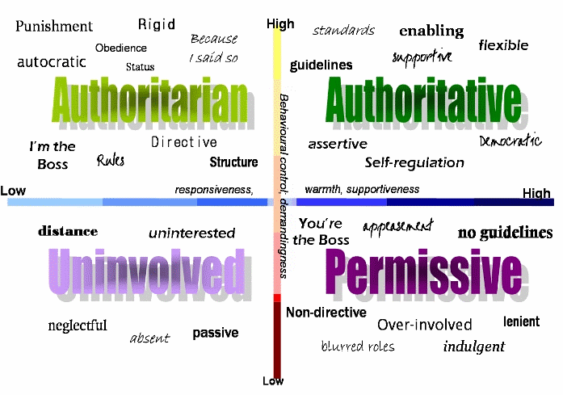
Each has its strengths and weaknesses (except, in my opinion, the uninvolved parent), and many parents pick and choose elements of each one in determining what works best for them. Children play the most significant part in that process: what are they most responsive to? Research indicates that authoritative parenting is the best because it allows the parents to have just enough control and the child(ren) just enough independence to learn and grow. Placing too many restrictions on children inhibits their ability to mature and become independent, and the opposite of what is hoped for may occur when parents keep too tight a leash. On the other hand, not caring enough to the point of neglect can result in dire consequences.
The 1950’s and 1960’s (Baby Boomers)

(photo courtesy humboldtsentinal.com)
As time changes, so have acceptable methods of parenting. What was considered appropriate in 1950, for example, is no longer in 2014, and what has happened recently with Adrian Peterson has proven that. In the post WWII era, the typical American family was, of course, a father, mother, and a few children. While the men typically worked to provide for their family, mothers stayed home to raise children and tend to house hold duties, many isolated from much else. Males of this generation were most “likely to display a more authoritarian parenting style” (Zervides and Knowles 65) while mothers a more authoritative parenting style. “Fathers” were “seen as providers and firm disciplinarians rather than as nurturers.” (Zervides and Knowles 73) Mothers received most of the blame if things went awry. When the sixties came along, and people began to question and challenge everything, parenting was also on the list. It was a very volatile time in our country, where passionate people united to support common causes, including equal rights for African Americans and women, the latter who felt guilt about wanting to be more than a housewife and a mother. The 1960’s was the end to the rigidity of the 50’s, and as parenting has evolved in recent decades, it’s easy to see why what was considered appropriate in the 1950’s no longer is today. We have gradually begun to place “greater emphasis on the parent-child relationship” and to encourage “a more child-centered approach to parenting.” (Zervides and Knowles 72)
The 1970’s and 1980’s (Generation X)

(photo courtesy donberns.com)
In the 1970’s and 80’s more women began to join the workforce, many out of financial necessity, some because of divorce. “For Generation X members, ‘protective’ is the key word to their parenting, largely because their families were less stable. They want…a balanced life with more hands-on help from dads.” (Jayson) In an effort to remain proactive, many “parents arranged more structured, supervised activities for their children”…hoping to… “maximize”…their “physical, social, and intellectual development.” (Mintz) In addition, as more research and studies were done regarding effective parenting, advocacy organizations and government agencies were created to increase awareness of “threats to children’s well-being… health and safety.” (Mintz) Parents began investing in their children, spending more time, money and resources on them. The aspirations they had for their children were much higher than what baby boomers had for theirs.
The 1990’s and 2000 (The Millennials)

(photo courtesy deadlinedetroit.com)
With the 1990’s came much more relaxed attitudes similar to those of the 1960’s. The desktop computer and the evolution of the internet, the World Wide Web, transformed the landscape of the world. Instead of worrying about their children listening to Elvis Presley parents now cringe at what their children are exposed to and engaging in on their computers, cell phones, social media, etc. Technological advances have changed how we parent our children, dare I say, how we are allowed to parent them. Children now more than ever feel a greater sense of independence at a younger age, and more empowerment. There is not much privacy anymore. We have access to so much more information about the world we live in that it is frightening. There is no filter from reality. They are exposed to everything. Is this a good thing? Only time will tell. Evolution is good, right? But it has not been for Adrian Peterson, or for any other parent who has abused their child, who cannot evolve with the times to understand that it is just no longer acceptable to discipline children that way. We moved from that long ago, when Dr. Spock encouraged “a more child-centered approach to parenting.” (Zervides and Knowles 72) We have moved on, thankfully, from the “do as I say, not as I do” mentality.
While it seems easy to judge what others did so many years ago, we must understand that there was a purpose behind it. Research indicates that “children acquire gender typed preferences and behaviors from their parents and model their own behavior on their same-sex parent.” (Zervides and Knowles 73) Does that excuse what Adrian Peterson did to his young son, because his father did it to him? Of course not, but it does help to explain it. Yet today “there can be no doubt that contemporary parenting is more stressful than it was in the early postwar era. Today’s parents are beset by severe time pressures and work-related stress…their children are growing up in a violent, sex-saturated environment, where the allure of drugs, alcohol, cigarettes and consumer products is widespread.” (Mintz) But we have to develop from what we have learned as a result of past behavior, do we not? Do we not now live in a society where, it has been obvious for years, it is not ever right to strike a child? I don’t know how anyone can learn love from that.

Works Cited
Blair, Sampson Lee, and Patricia Neff Claster. Visions Of The 21St Century Family : Transforming Structures And Identities. Bingley, U.K.: Emerald, 2013. eBook Collection (EBSCOhost). Web. 17 Sept. 2014.
Browne, Blaine T., and Robert C. Cottrell. Modern American Lives : Individuals And Issues In American History Since 1945. Armonk, N.Y.: M.E. Sharpe, 2008. eBook Collection (EBSCOhost). Web. 17 Sept. 2014.
Coleman, Marilyn, Lawrence H. Ganong, and Kelly Warzinik. Family Life In 20Th-Century America. Westport, Conn: Greenwood Press, 2007. eBook Collection (EBSCOhost). Web. 15 Sept. 2014.
Jayson, Sharon. Round and Round They Go. USA Today. USA Today, 27 Sept 2006. Web. 15 Sept. 2014.
Mintz, Stephen. Parenting. Faqs. The Gale Group, 2008. Web. 20 Sept. 2014.
Stearns, Peter N. Anxious Parents: A History of Modern Childrearing in America. New York: New York University Press, 2003. eBook Collection (EBSCOhost). Web. 15 Sept. 2014.
Zervides, Sophia and Knowles, Ann. “Generational Changes in Parenting Styles and the Effect of Culture.” E-Journal of Applied Psychology 3.1 (2007): 65-75. Web. 20 Sept. 2014.

